**LOAN APPLICATION DOCUMENTATION**

**Welcome page**

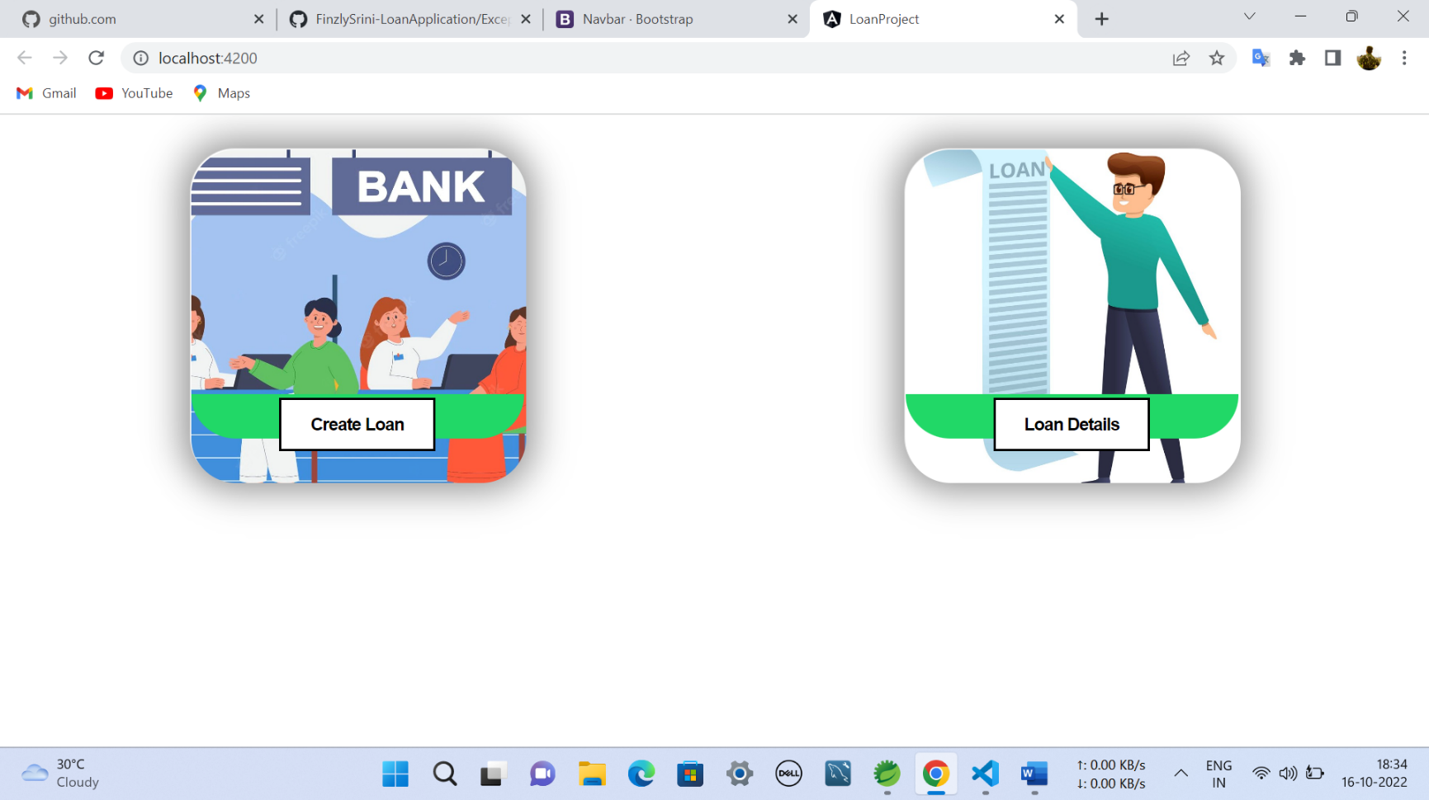

fig:1

**Create Loan:**

Creates new loan for Customer

**Loan Details:**

Displays all loans of Customer

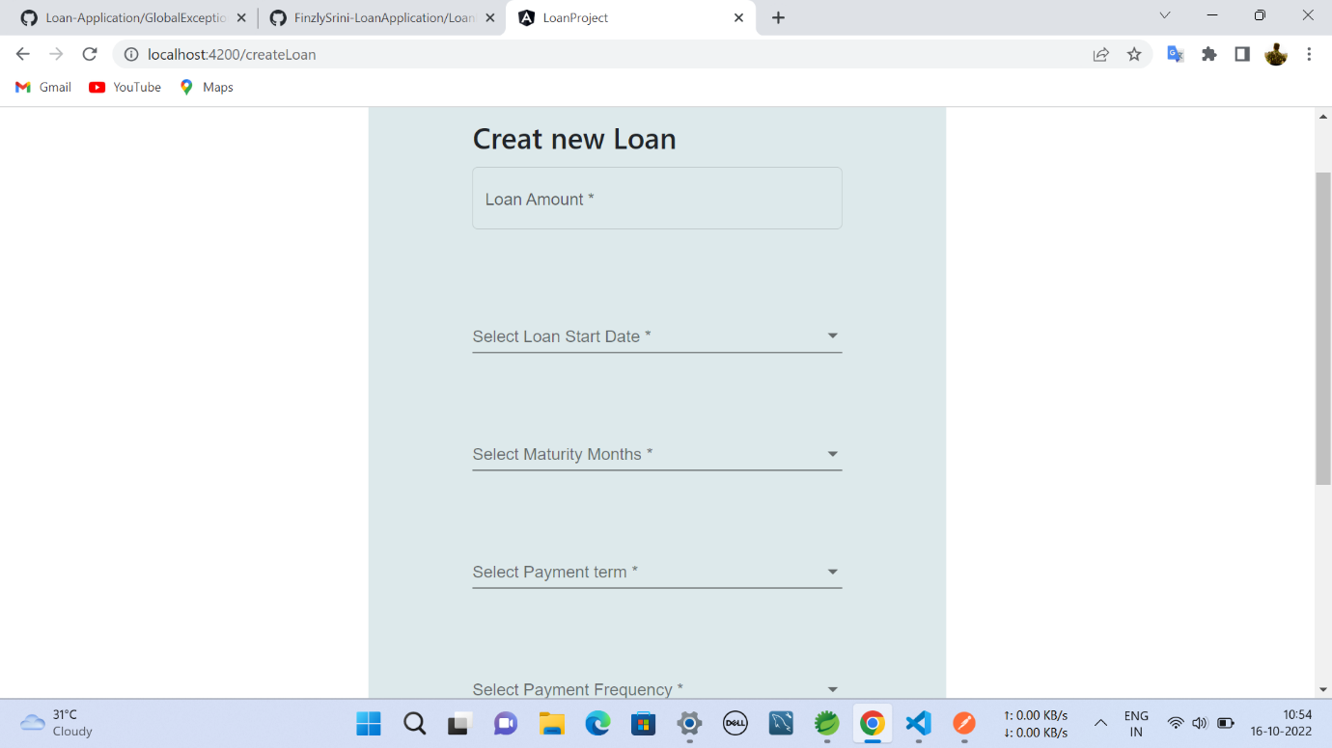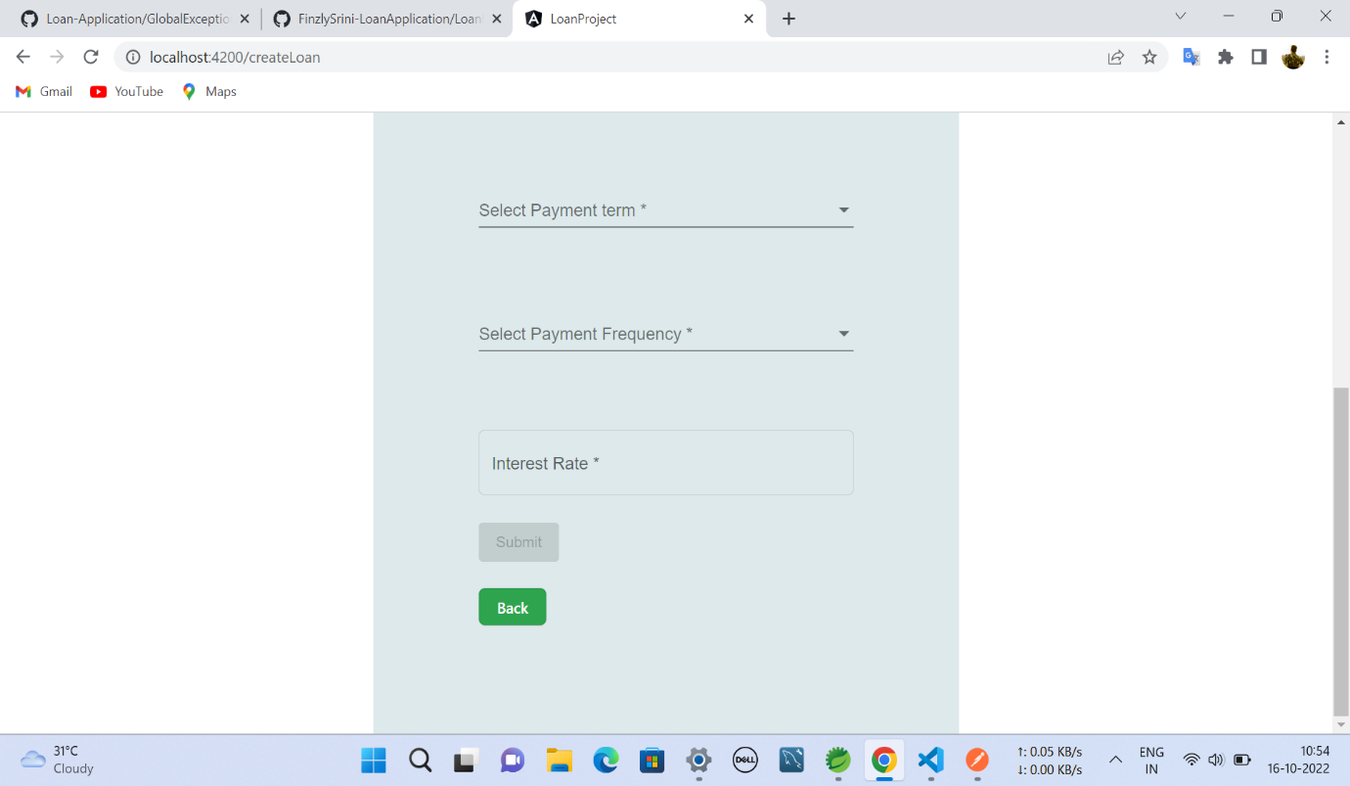

fig:2

* On getting into **Create Loan** it takes to you Loan creation page as shown in Fig:2

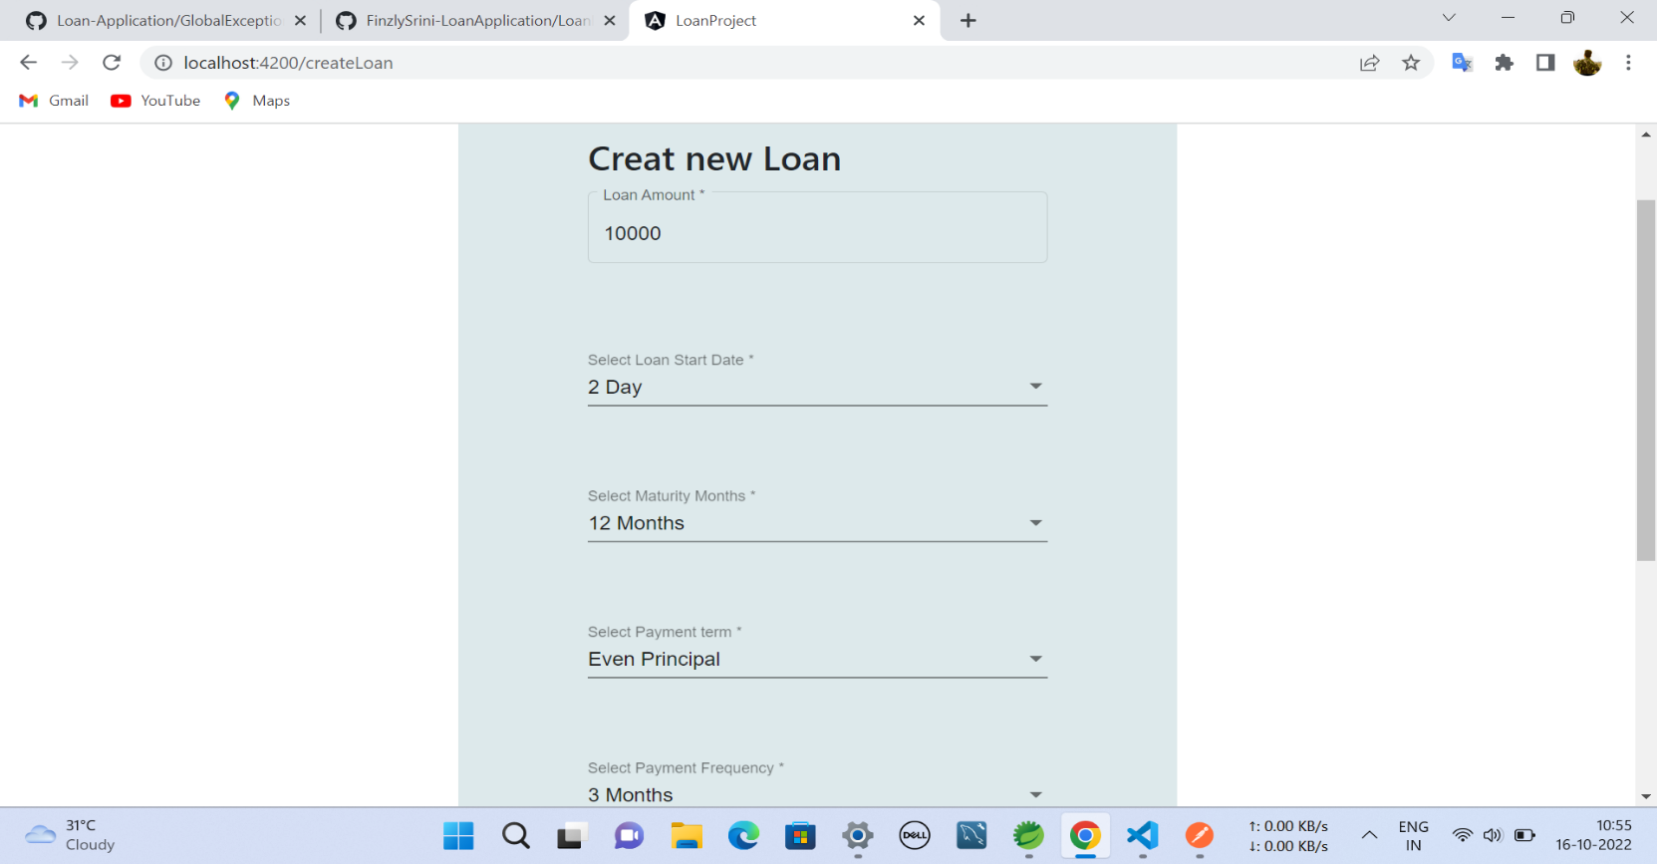

fig:3

* Enter the Principal amount (only numbers and positive values are allowed)

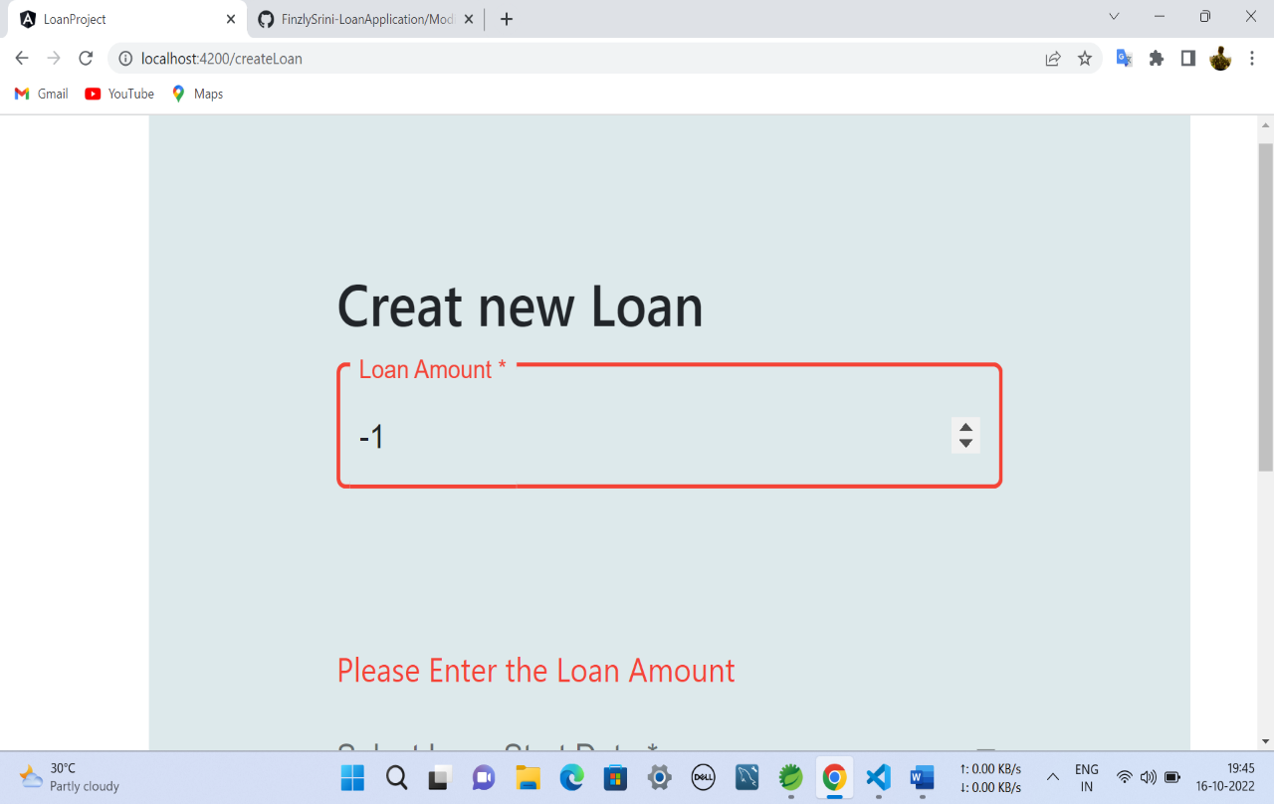

fig:4

* 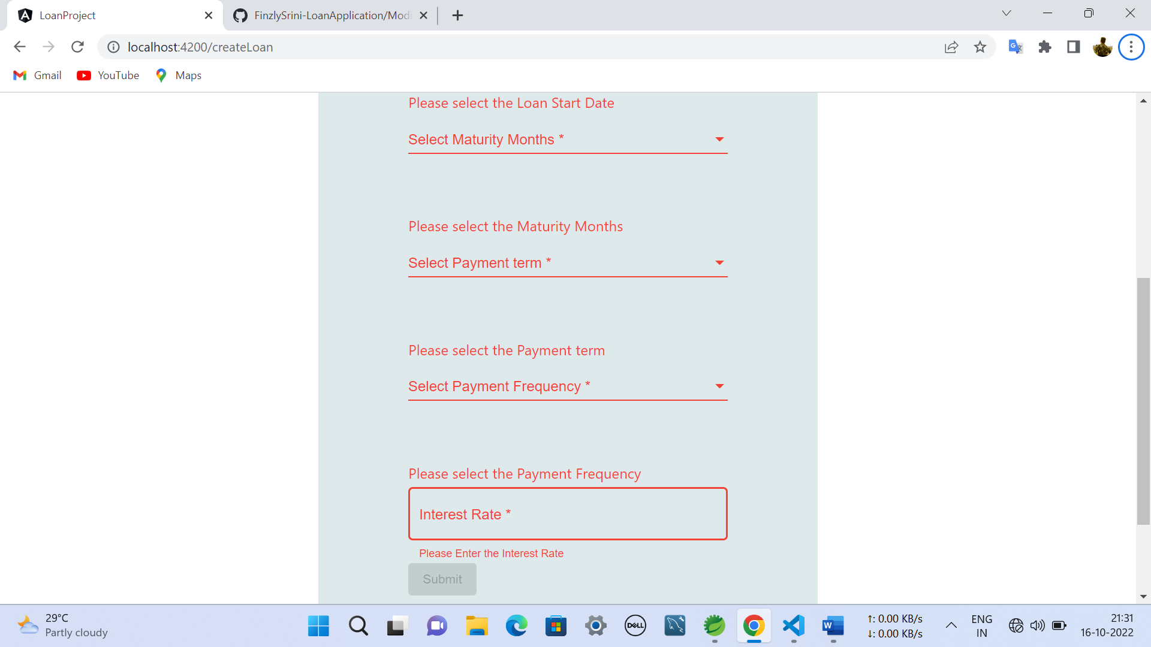While entering negative value it won’t accept

fig:5

If we didn’t give any input then it will show error as shown fig:5

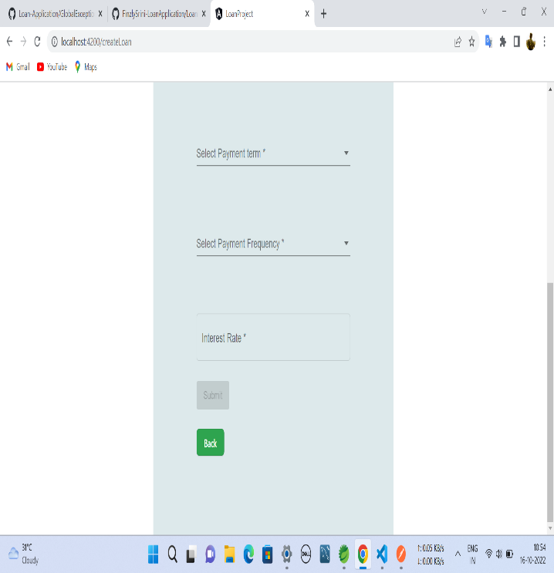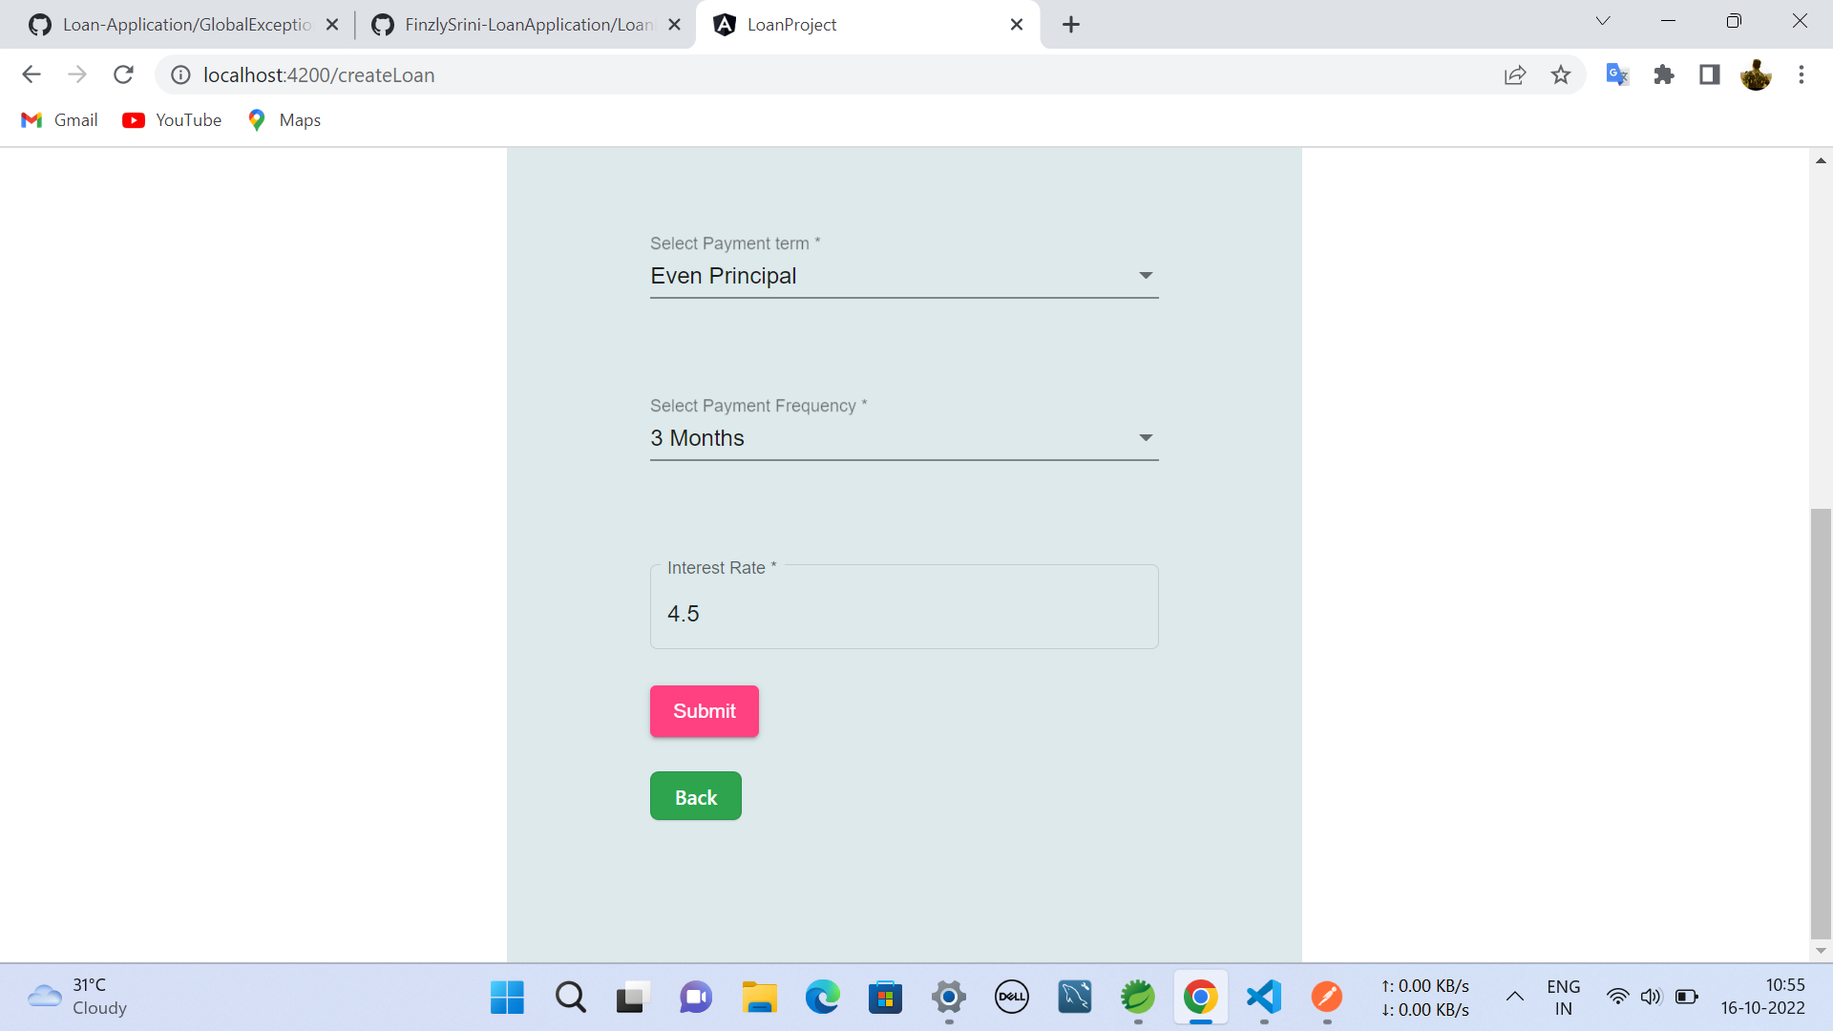 fig:6.1 fig:6.2

* Only after entering all the fields **Submit** button will display

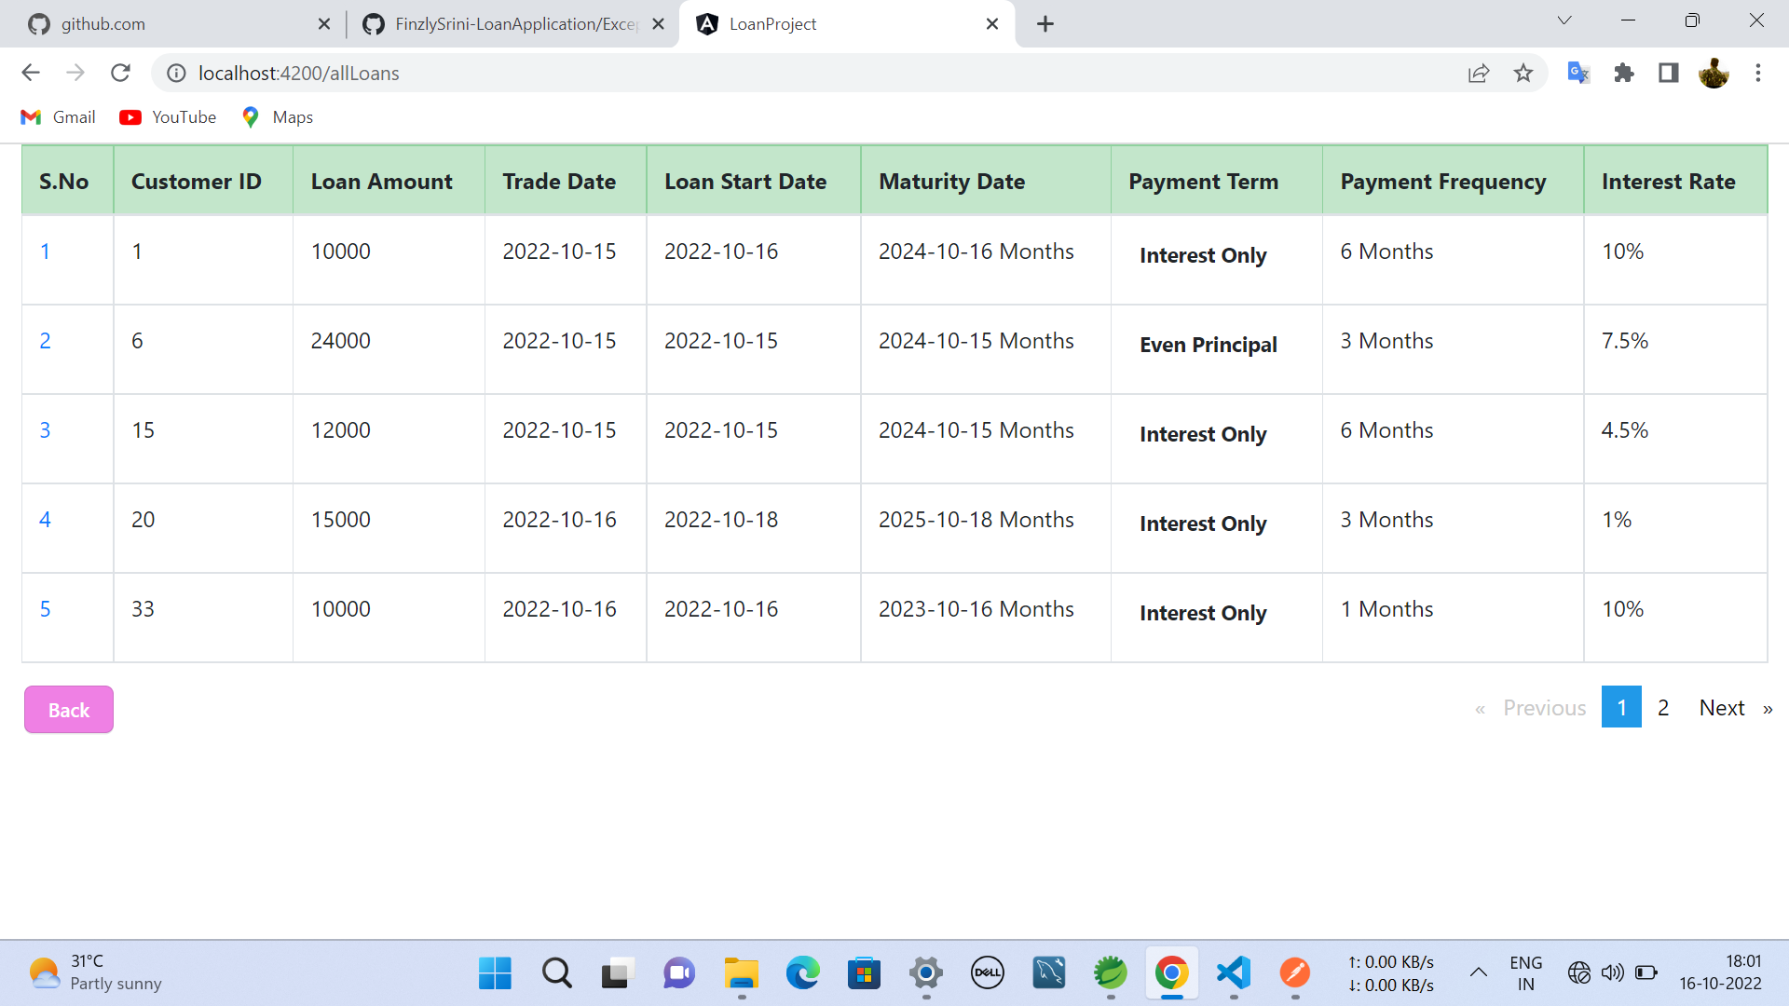

fig:7

* **Loan Details** of all *customer* will be displayed on clicking Loan Details.

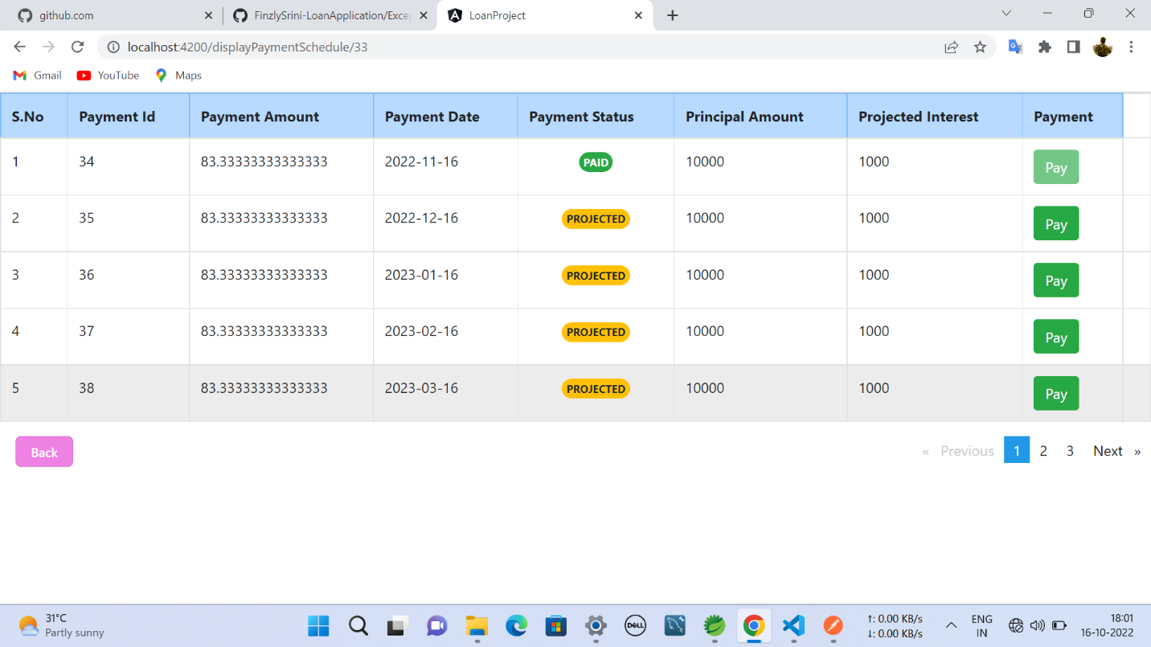

fig:9

* On clicking particular **S.No(Customer name)** you can view all the loans of the particular customer.

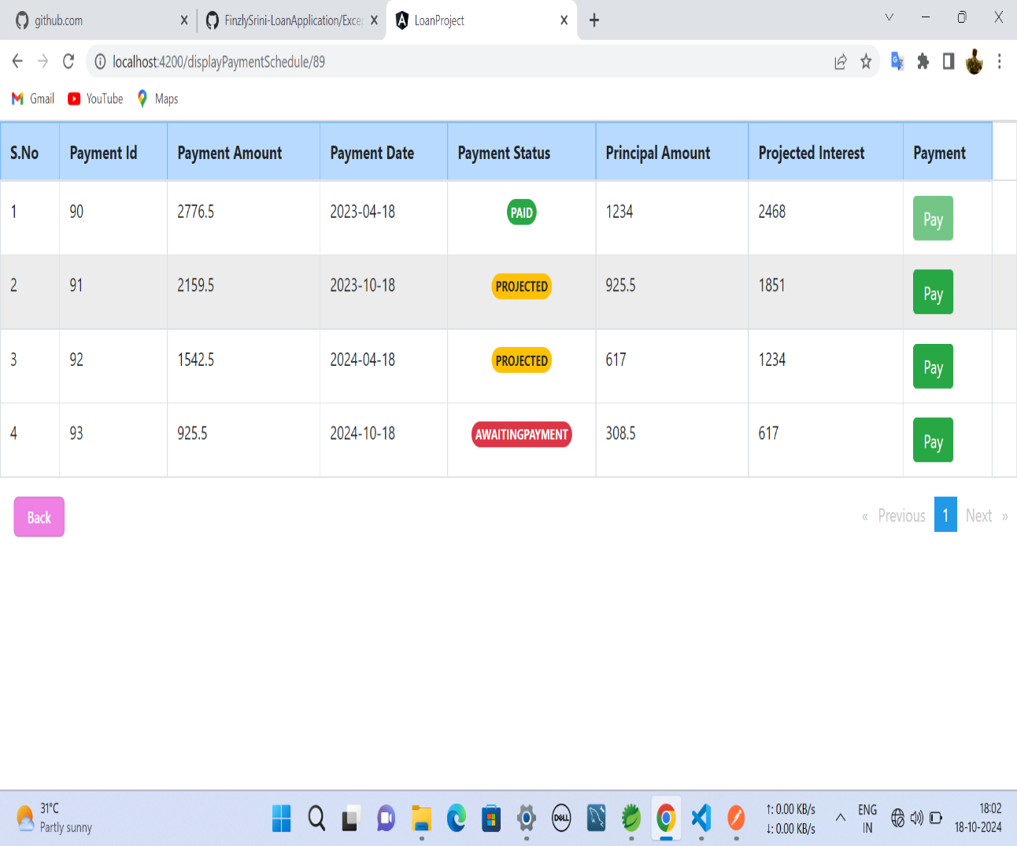

fig:10

* **Payment status** will be shown as shown fig:10
* Untill before the due date Payment Status will appear **PROJECTED.**
* On due Date Payment status will show **AWAITINGPAYMENT.**
* After completion of payment Payment Status displays **PAID.**
* Pay option will be displayed untill the payment completes, and after completing the payment it will disapears.

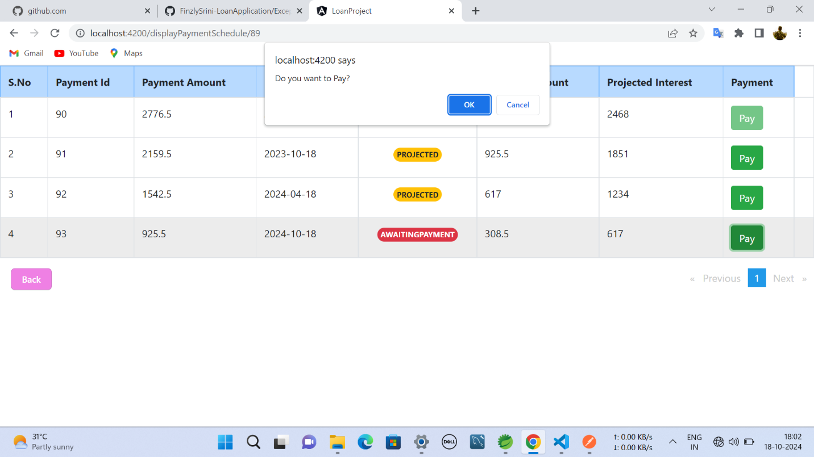

fig:11

* While **PAYING,** it ask customer to verifies and then proceeed Payment process further.

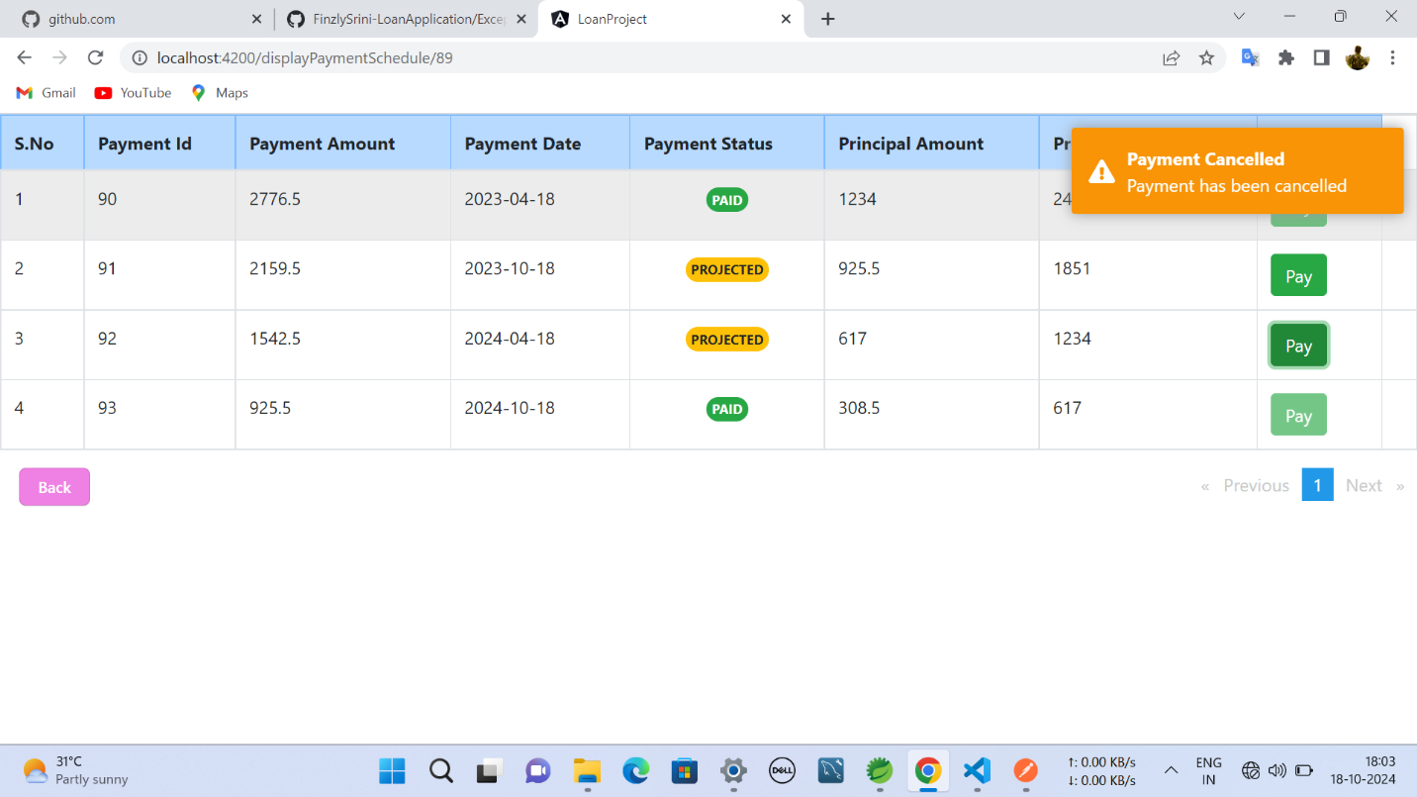

fig:12

* If payment has **cancelled** then the toaster message will appear as shown in fig:12.